

American International University-Bangladesh (AIUB)
Faculty of Science and Technology

Evidence-Driven Differential Diagnosis: A Machine-Learning Framework Integrating Structured Patient Data and Metadata-Derived Human-Readable Clinical Evidence

S. M. MASUM - 21-45807-3
SUSMITA ALAM ATHINA - 21-45411-3
FARIA NUSRAT BINTE - 20-44284-3
SAGOR SAHA - 21-45074-2

A Thesis submitted for the degree of Bachelor of Science (BSc) in
Computer Science and Engineering (CSE) at
American International University Bangladesh (AIUB)

Summer 2024-2025 Semester Submission Date: 5 December 2025
Declaration

All the information presented in this thesis, unless otherwise indicated by proper in-text citations, is unique to our research group, and has never been published or written by any other party before. It is directly obvious that the efforts of other people are not ignored in our work. This declaration includes assistance with statistical analysis, survey design, data analytics, vital technological processes, professional editorial support, financial sponsorship and any other original research that is used or recorded in this thesis. The work we have put since we started developing the very thesis is the major source of its substantive content.

We recognize that the owner(s) of the copyright of all the material in the thesis have exclusive rights to the same. Where permission is necessary owing to the co-authorship, we have obtained the consent of the co-authors and in cases where it is necessary we have sought the permission of the relevant copyright holder to use the material in question in the thesis.

_______________________________  S. M. Masum  21-45807-3  Department of Computer Science | _______________________________  Susmita Alam Athina  21-45411-3  Department of Computer Science

_______________________________  Faria Nusrat Binte  20-44284-3  Department of Computer Science | _______________________________  Sagor Saha  21-45074-2  Department of Computer Science

Approval

The thesis titled “Evidence-Driven Differential Diagnosis: A Machine-Learning Framework Integrating Structured Patient Data and Metadata-Derived Human-Readable Clinical Evidence” has been submitted to the following respected members of the board of examiners of the department of computer science in partial fulfilment of the requirements for the degree of Bachelor of Science in Computer Science on 5th December 2025 and has been accepted as satisfactory.

SYEDA ANIKA TASNIM S M ABDULLAH SHAFI
Lecturer & Supervisor Lecturer & External
Department of Computer Science Department of Computer Science
American International University-Bangladesh American International University-Bangladesh

DR. DEBAJYOTI KARMAKAR
Associate Professor & Head (UG)
Department of Computer Science
American International University-Bangladesh

PROF. DR. DIP NANDI MASHIOUR RAHMAN
Professor & Associate Dean Sr. Associate Professor & Dean
Faculty of Science and Technology Faculty of Science and Technology
American International University-Bangladesh American International University-Bangladesh

Acknowledgement

It is our utmost pleasure to thank Almighty because his blessings helped us to accomplish this study.

Our highly respected supervisor, Syeda Anika Tasnim, ma'am, has been very critical of us, guiding us and advising us throughout the study, but she has been very instrumental in her technical advice. We also wish to thank the faculty of the Department of Computer Science at the American International University Bangladesh (AIUB) in terms of their informative discussions and academic assistance.

Lastly, we want to recognize our families and friends to support us in this endeavor with patience and encouragement which was unending.

[Note: This thesis did not involve any professional editorial service.]

Author Contribution
21-45807-3 | 21-45411-3 | 20-44284-3 | 21-45074-2 | Comments
 | Perform as effective individual
3 | 3 | 3 | 3 | Demonstrated clear reasoning and logical analysis.
3 | 3 | 3 | 3 | Feedback was taken seriously, and improvements were seen in every phase.
3 | 3 | 3 | 3 | High-quality output delivered.
3 | 3 | 3 | 3 | Members were independently proactive, and task driven.
 | Perform as effective team member/leader
3 | 3 | 3 | 3 | Everyone owned their parts and met deadlines.
3 | 3 | 3 | 3 | Everyone contributed equally to both research and implementation.
3 | 3 | 3 | 3 | Excellent coordination and mutual respect shown.
3 | 3 | 3 | 3 | Seamless cooperation and support in all tasks.
 | Perform as effective team member/leader
3 | 3 | 3 | 3 | Delivery was confident and clear.
3 | 3 | 3 | 3 | Speech was audible, engaging, and professional.
3 | 3 | 3 | 3 | Demonstrated genuine interest in topic throughout presentation.
3 | 3 | 3 | 3 | Slides and tools were used effectively to engage the audience.
Faria Nusrat Binte
Susmita Alam Athina
Sagor Saha
S. M. Masum

0 – 3 Points
0 – 3 Points
0 - 3 points
Critical thinking
Reflection on Feedback

Quality of Work
Self-Directed
Taking Responsibility
Contribution
Collaboration
Working with others
Creativity & Tool Use
Enthusiasm
Voice and Tone
Presentation Delivery
Thesis Planning
Tasks | Schedule Data | Execution Data
1. Planning | 29-Jun-25 – 18-Jul,2025 | Topic Finalization & Team Formation
2. Literature Review | 19-Jul-25 – 7-Aug,2025 | Background Study & Literature Review
3. Dataset Implementation | 8-Aug-25 – 27-Aug2025 | Dataset Collection / Survey
4. Methodology and Result Demonstration | 28-Aug-25 – 16-Sep,2025 | Model Development & Testing
5. Conclusion and Introduction | 17-Sep-25 – 26-Oct ,2025 | Objective Framing & Tool Selection
6. Writing Thesis Report | 27-Oct-25 – 15-Nov,2025 | Thesis Writing & Refinement
7. Submission | 16-Nov-25 – 6-Dec,2025 | Final Submission & Presentation Prep

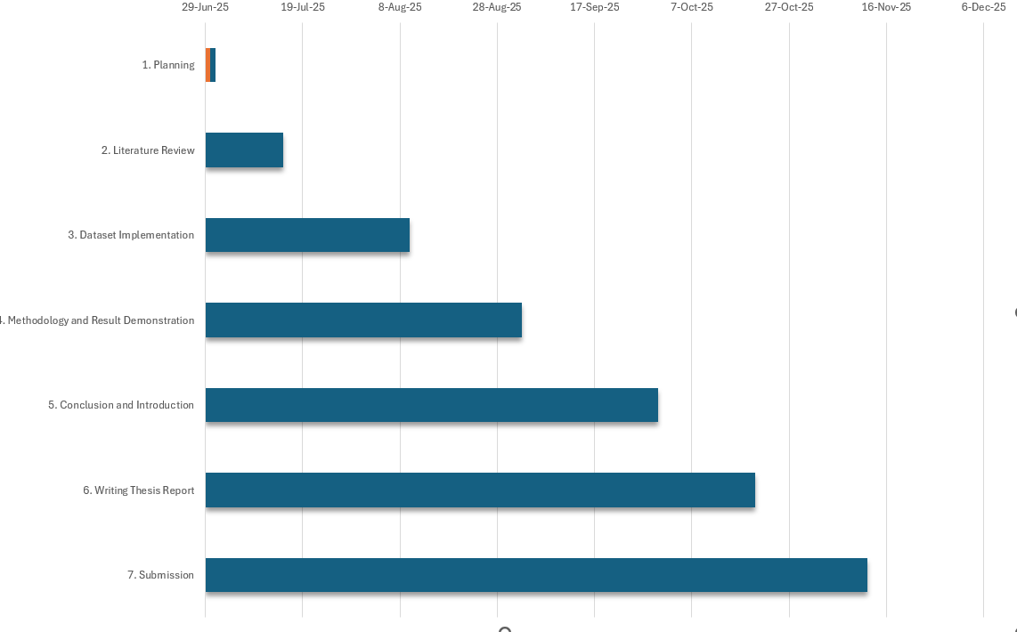
Gnatt Chart: The Gnatt chart below visually presents the entire project schedule, including the duration and overlap of tasks. Each task is shown as a bar, starting from its planned start date and ending at the scheduled completion date.
Figure 1: Workflow diagram of Evidence-Driven Differential Diagnosis
Table of Contents
Declaration | 2
Approval | 3
Acknowledgement | 4
Author Contributions | 5
Project-Thesis Planning | 6
Table of Content | 7-8
List of Figures | 9
List of Tables | 10
List of Abbreviations | 11
Chapter 1: Introduction | 12
1.1 Summary of studies and limitations | 13
Chapter 2: Research Methodology | 19
2.1 Dataset Overview and Description | 19
2.2 Dataset Exploration | 20
2.3 Workflow | 24
2.4 Feature engineering | 25
Chapter 3: Model Training | 25
3.1 logistic regression classifier | 25
3.2 Training Multiple Classical Machine Learning Models | 26
3.3 Random Forest Classifier | 26
3.4 RidgeClassifier | 27
3.5 SGD Classifier | 27
3.6 Linear SVC | 27
Chapter: 4 Result | 27
4.1 Overall Model Performance | 27
4.2 Linear and Margin Based Model Performance | 28
4.3 The Ensemble and Tree-Based Models | 28
4.4 LightGBM Underperformance Analysis | 29
4.5 Clinical implications of high top-K Accuracy | 29
4.6 Summary of Key Findings | 29
4.7 An Interpretability Motivation More than an Accuracy Motivation | 30
4.8 Reason behind a Chatbot-Based Discovery | 30
4.9 Human-readable Clinical Evidence Extraction | 30
4.10 Top K Misclassification Scenario Analysis | 31
4.11 Generated Explanations | 31
4.12 Explainable Clinical Chatbots Implications: | 31
Chapter 5: Discussion | 32
Chapter 6: Conclusion | 33
Chapter 7: References | 33

List of Figures
Figure 1: Workflow diagram of Evidence-Driven Differential Diagnosis
Figure 2: Top 20 most frequent Disease in all splits.
Figure 3: Age distribution in all splits.
Figure 4: Distribution of Evidence Count per Patient Across Train, Validation and Test Sets.
Figure 5: 20 most frequently occurring evidence.
Figure 6: 20 most frequent evidence (Human Readable)

List of Tables

Table 1: | All files are provided with the dataset. | 19
Table 2: | Description of each column items in the dataset. | 19
Table 3: | Sample of the dataset. | 20

List of Abbreviations
Abbreviation | Full Form
AI | Artificial Intelligence
DDx | Automatic differential diagnosis
ML | Machine learning
SVM | Support vector machine
DL | Deep Learning
LLM | Large language models
ASD | Autism spectrum disorder
CD | Conduct disorder
ADHD | Attention deficit hyperactivity disorder
ALS | Amyotrophic lateral sclerosis
MNDs | Many motor neuron disorders
LMND | Lower motor neuron.
QA | Question answering
SLL | Small lymphocytic lymphoma
CLL | Chronic lymphocytic leukaemia
SAT | Subacute Thyroiditis
CEUS | Contrast-Enhanced Ultrasound
GILs | Gastrointestinal leiomyomas
GISTs | Gastrointestinal stromal tumors

Introduction:
Differential diagnosis is an important phase in clinical diagnosis. Differential diagnosis is the cognitive process of producing and prioritizing a list of probable diagnoses for a given clinical presentation, is one of the most important and difficult skills a medical student (or indeed, a clinician at any level of experience) must develop [1]. By conducting efficient differential diagnosis at the early phase of the diagnostic process, physicians can reach the correct diagnosis timely [2]. For example, when a patient arrives with a high fever, headache, and severe sore throat, a physician may initially consider tonsillitis as the most likely diagnosis. At the same time, the physician may also keep dengue and typhoid in mind as other possible causes, since their early symptoms can appear similar. This way, if tests later show that the patient does not have tonsillitis, the physician can quickly shift the diagnostic plan toward dengue or typhoid because those alternatives were already considered from the start. Failing to distinguish the correct disease may result in medical error and safety of a patient. Medical errors are among the most critical safety issues in today's healthcare. Medical errors cause the most significant damage (human and economic) to the public [5]. Atypical patient presentations, the failure to consider other diagnoses, cognitive burden, and lack of time to think were reported to be the most commonly perceived factors contributing to diagnostic errors in an outpatient setting [13].
Automatic differential diagnosis (DDx) involves identifying potential conditions that could explain a patient’s symptoms and its accurate interpretation is of substantial significance [18]. In recent years, machine learning (ML) methods have become a hot topic and have gradually become the standard bearer of modern computing methods [6]. The term machine learning refers to the subdomain of statistics and computer science focusing on the elaboration of complex algorithms able not only to build models from often huge datasets but also to improve their accuracy, imitating the way humans learn [16]. Artificial intelligence (AI) is rapidly being applied to the medical field. AI has demonstrated its capability to capture subtle connections from a multitude of multiparametric datasets, enabling the discovery of hidden relationships in data and handling more complex tasks than traditional methods. ML refers to the ability of AI systems to extract patterns in raw data without being explicitly programmed to do so. It involves training a model through the utilization of data with known ground-truths to subsequently generate predictions for new, unseen inputs [14]. Multiple ML tools that include mostly supervised approaches such as support vector machine, gradient boosting, and random forest showed promising results by applying these algorithms to various sources of data: socio-demographic information, EEG, language, digital content, blood biomarkers, neuroimaging, and electronic health records [16]. Common ML algorithms include convolutional neural network model, random forest, gradient lifting decision tree, extreme gradient enhancement, support vector machine (SVM), Bayesian network classifier, unsupervised clustering, unsupervised self-organizing mapping, and supervised enhanced regression algorithm, etc. These methods were first widely used in non-medical data, and in recent years have also been used in clinical research [6]. Deep learning (DL)–based artificial intelligence may have different diagnostic characteristics than human experts in medical diagnosis[12]. The use of artificial intelligence (AI) is expected to reduce diagnostic errors in patients. Provided AI-driven differential-diagnosis lists with basic patient information such as age, sex, risk factors, past medical history, and current reason for medical appointment could improve the diagnostic accuracy of physicians[13].
Many studies aim to do differential diagnosis on a pair of disease[4], [6], meaning to distinguish between closely related diseases with the help of machine learning models. One study suggest that the diagnostic accuracy of physicians using AI-driven AMHT systems may depend on the diagnostic accuracy of AI [13]. Our aim is to propose a model that could do differential diagnosis across various disease. Differential diagnosis (DDx), a critical component of clinical care, involves generating a list of potential conditions that could explain a patient’s symptoms [18].
Large language models (LLM) have shown promise in assisting medical decision-making. LLMs utilize transformer-based architectures to model linguistic and contextual relationships across diverse datasets. This allows them to interpret clinical notes, imaging reports, and other structured clinical data within a unified context. These abilities give LLMs exciting potential for applications in medicine such as facilitating research, serving as virtual assistants, and aiding in clinical and laboratory diagnoses [22].
Summary of studies and limitations:
DDSS seems to be a practical technology in improving the diagnosis process because it can generate any useful differential diagnosis based on all clinical manifestations. The DDSS however has its own disadvantages. The greatest shortcoming seems to be the inefficiency of consistently positioning the right diagnosis at the top of the DDSS list of the diagnostic list. Doctors usually consider three or so (depending on the case) of the diagnoses researched in their day-to-day clinical practice. The actual differential diagnostics permits physicians to make only three choices out of the list of the top 20 differential diagnoses suggested by the DDSS. Due to this, physicians might not be capable of making the right diagnosis based on the list of various diagnoses offered by the DDSS [2].
This article presents a scalable benchmarking approach for evaluating health AI systems and uses August, an AI-powered conversational chatbot, to illustrate its use. August greatly outperformed conventional symptom checkers in systematic testing, achieving top-one diagnostic accuracy of 81.8% (327/400 cases) and top-two accuracy of 85.0% (340/400 cases). When compared to traditional symptom checkers, the system required 47% fewer questions and showed 95.8% accuracy in specialist referrals. This study contributes to the responsible development and application of AI in clinical contexts by offering a repeatable methodology for assessing healthcare AI systems. Restrictions: Vignettes are condensed depictions that frequently fall short of capturing the subtleties of unique patient presentations, such as inconsistent symptom reports, co-morbidities, and erratic patient behaviors. [3].
The machine-learning models' diagnostic performance was comparable to the experts' judgement and more accurate than that of the non-expert physicians. To the best of our knowledge, this is the first study that uses different machine-learning models to distinguish between TBM and VM. Despite this, their diagnostic performance was inferior to that of earlier research. Additionally Due to the limited amount of data used for learning, their study had limitations [4].
They created and released a learning-to-rank-based clinical decision support system. The primary goals are to prevent medical professionals from making incorrect diagnosis and to assist internists and general practitioners with differential diagnoses. "A physician inputs a patient's symptoms, findings, and test results to the system, and the system outputs a ranking list of possible diseases is one of the primary features" [5].
Carried out a study that used deep learning classification methods for PMN differential diagnosis, investigated the best classification algorithm for PMN recognition, and supplied data references for PMN diagnosis research. Their research examined the potential for diagnosing PMN patients using IgG and anti-PLA2R, which may offer a reliable foundation for using it as a valuable biomarker to direct the diagnostic and treatment choices [6].
Sought to develop two multi-class machine learning classifiers based on two distinct sets of features for the differentiation of FDG PET scans of patients with NC and the most prevalent dementia syndromes (AD, DLB, and FTD). The algorithms' classification accuracy was then compared to expert visual reading and gold standard diagnosis. We also looked at each illness type's distinctive characteristics [7].
Autism spectrum disorder (ASD) diagnosis is a difficult and time-consuming process that calls for a high degree of clinical knowledge and experience. Because social interaction and communication difficulties are common in a variety of other conditions and behaviors, such as affective and anxiety disorders, attention deficit hyperactivity disorder (ADHD), and conduct disorder (CD), diagnosing ASD is particularly difficult. In light of certain differential diagnoses (such as anxiety, ADHD, and CD), the current work sought to build optimized models for ASD diagnosis using machine learning techniques for the first time. Additionally, we tried to pinpoint the ADOS items that are especially significant in the context of these particular models [8].
Many motor neuron disorders (MNDs) have many overlapping symptoms, making early differential diagnosis very difficult. Using only blood data, we want to characterize and distinguish patients with selective involvement of the lower motor neuron (LMND) from those with involvement of both upper and lower motor neurons (i.e., patients with amyotrophic lateral sclerosis, or ALS). Our findings demonstrate that, using only blood data, we were able to develop subject-independent classifiers for the differential diagnosis and prognosis of lower motor neuron disease (LMND) and amyotrophic lateral sclerosis (ALS) with impressive average accuracy (up to 94%) [9].
Pleural effusion is a prevalent clinical issue with a wide range of potential diagnosis. While cancer, pneumonia, and tuberculosis are common causes of pleural effusions, it can be difficult to distinguish between these serious illnesses in clinical practice. For the differential diagnosis of the common causes of pleural effusions, our LGB model performed satisfactorily. Clinicians may find this model useful in understanding the main differential diagnosis of pleural illnesses [10].
Our goal was to use machine learning techniques and preliminary test results to perform differential diagnosis of thyrotoxicosis. Seven machine learning methods were used to calculate the accuracy of differential diagnosis. This study's use of patients who reside in iodine-rich environments is one of its limitations. Thyroid scintigraphy results can be fed into machine learning models to improve algorithm performance, especially in the iodine-deficient region where thyrotoxicosis caused by toxic nodules is common and scan false-negative rates are low [11].
Three key conclusions emerged from the current investigation. First, based on reading vignettes created by AI-driven AMHT systems, doctors' diagnostic accuracy was not improved by the differential-diagnosis list generated by these systems. Second, two independent predictors of accurate diagnosis were the doctors' experience and the accuracy of the AI-generated diagnosis. Third, commission errors were independently predicted by male sex and inexperience. These findings imply that the diagnostic precision of AI may have an impact on the diagnostic precision of doctors utilizing AI-driven AMHT systems [13].
An overview of AI models created to distinguish between cardiomyopathy phenotypes, the treatment of cardiomyopathies, and the advantages of their use in clinical practice are the goals of this paper. The variability of the data gathered, repeatability problems, the need for both internal and external validation, interpretability issues, and ethical and legal considerations are some of the limitations [14].
More nuanced distinctions between benign and malignant BI-RADS 4A lesions can be detected using AI. These findings serve as a reminder of how important it is to pay close attention to the margin and internal echo. AI-provided morphological and texture data can help physicians diagnose such unusual benign and malignant lesions more accurately. In order to determine the usefulness of AI in the differential diagnosis of BI-RADS 4A benign and malignant lesions, the current study used AI to assess the ultrasonic morphological and textural characteristics of these lesions [15].
Reducing the effects of psychotic diseases requires prompt diagnosis and adequate treatment. Given that psychosis manifests differently in men and women, one of the field's primary constraints is the absence of biological sex-based stratification of results; as a result, customised identification methods and data analysis techniques are required [16].
Machine learning (ML) has the potential to transform psychiatry and enhance patient outcomes. They suggest a change in emphasis, arguing that ML models should be prioritised in order to improve prognosis predictability, therapy selection, and prevention. Consequently, this transdiagnostic objective should be the focus of data selection and outcome factors. In this manner, ML can be used to assist medical professionals in developing individualised treatment plans for people with mental illnesses [17].
Large language models (LLMs) have shown impressive diagnostic accuracy, but their capacity to produce high-quality DDx explanations is still poorly understood. This is mostly because there are no specialised evaluation datasets available, and complicated reasoning in LLMs presents intrinsic difficulties. We suggested a brand-new framework called Dual-Inf that may efficiently use LLMs to produce superior DDx explanations. big language models (LLMs) trained on big corpora, like ChatGPT, have demonstrated impressive ability in a variety of clinical contexts in recent years, such as disease detection, clinical text summarisation, and medical question answering (QA). With 570 clinical notes from publicly accessible medical exercises in nine specialties—cardiovascular, digestive, respiratory, endocrine, neurological, reproductive, circulatory, skin, and orthopaedic diseases—we created Open-XDDx, a well-annotated dataset for explainable DDx [18].
The effect of human-large language model (LLM) collaboration on the precision and effectiveness of brain MRI differential diagnosis was examined in this work. To investigate the function of human-LLM cooperation in brain MRI differential diagnosis, they carried out usability tests. Our findings imply that, in comparison to traditional internet search, an LLM-assisted workflow may improve diagnostic accuracy. There was no discernible impact on reader confidence or interpretation times. There are a number of limitations to this study. First, our results may not immediately apply to readers with greater experience because only radiology residents with less neuroradiology experience were included. Second, human-LLM interactions were assessed in a controlled context rather than a real-world clinical scenario, where a heavy workload and frequent interruptions could change reader behaviour. Third, the intrinsic constraints of radiological diagnosis must be considered when evaluating the diagnostic performance of both readers and LLMs [19].
From March 2020 to September 2023, we collected data from peripheral blood, bone marrow, and lymph nodes of 120 patients at Zhengzhou University's First Affiliated Hospital. Of these, 64 had typical CLL, 10 had atypical CLL, and 46 had MCL. The World Health Organisation (WHO) classifies small lymphocytic lymphoma (SLL) and chronic lymphocytic leukaemia (CLL) as lymphoid neoplasms based on clinical, morphological, immunophenotypic, and genetic characteristics. The reproducibility of laboratory results in various clinical laboratories may change due to variations in reagents, devices (Machines), device settings, and analytic systems (Kaluza), which is one of the constraints of our study. Additionally, depending on the availability of all the aforementioned factors, each clinical laboratory or institution chooses its own approach and cutoff values to arrive at an optimal diagnosis. Thus, prospective studies and clinical trials can be used to validate the NSS in a greater number of samples from various hospitals worldwide [20].
Thyrotoxicosis is caused by either tissue damage, as in subacute thyroiditis (SAT), or thyroid hyperfunction, as in Graves' disease. Thyroid scintigraphy has historically been used to differentiate between these types, however differential diagnosis is crucial but can be difficult. The possibility of Contrast-Enhanced Ultrasound (CEUS) as a non-invasive method for distinguishing between destructive thyroid illness and hyperfunction is examined in this study .CEUS was used to assess both qualitative and quantitative perfusion parameters in 42 patients with untreated thyrotoxicosis. According to this pilot investigation, CEUS's quantitative and qualitative evaluations may be useful in the non-invasive differential diagnosis of thyrotoxicosis, thereby eliminating the requirement for scintigraphy and facilitating quick and precise treatment choices [21].
First, even though the sample size of 164 cases is significant, it might not be sufficient to fully reflect the range of pediatric radiological appearances. This may restrict how broadly our results can be applied. Second, real-world clinical presentations across various demographics may not be fully represented by the case examples, which were taken from a number of pediatric radiology textbooks [22].
The study found that deep learning techniques like IncepetionV3, which are based on chest radiographs, performed well for the differential diagnosis of congenital VSD and ASD. These techniques may be able to help radiologists with diagnosis, training, and education as well as decrease missing and incorrect diagnoses. A higher false detection rate for ASD indicated that the deep learning model was more sensitive to VSD cases than ASD. There were a number of restrictions on this study. First off, there weren't many examples in the test set, but we used fivefold cross-validation to lessen the effect of an imbalanced test set on the outcomes [23].
The study's goal was to find out if certain stains might distinguish between gastrointestinal leiomyomas (GILs) and gastrointestinal stromal tumours (GISTs). GISTs and GILs were the most prevalent submucosal lesions among gastrointestinal mesenchymal tumours globally. Even though this study offers a novel detection technique for the identification of GISTs and GILs, it is only a retrospective study, therefore it still needs to be confirmed in day-to-day work before it can be employed as a standard clinical diagnostic technique [24].
Using a stepwise decision tree approach, this study attempts to distinguish Kimura's disease (KD) from Sjogren's syndrome with mucosa-associated lymphoid tissue lymphoma (SS&MALT), neurofibromatosis (NF), and head and neck lymphoma. Based on MRI findings, the stepwise decision tree model demonstrated excellent accuracy in distinguishing KD from other head and neck conditions, providing a trustworthy diagnostic tool in clinical practice. There were just a few cases available for study because to the small sample size brought on by the rarity of KD [25].
Research Methodology:
Dataset Overview and Description :
large-scale synthetic benchmark dataset, which consists of approximately 1.3 million patients (49 pathologies, 110 symptoms and 113 antecedents). The patients of the dataset are described in terms of their socio-demographic information, a pathology that they suffer, a list of symptoms and antecedent of this pathology, and a differential diagnosis. It is the initial mass data that comprise of the differential diagnosis, and non-binary symptoms and antecedents. The dataset was developed on proprietary medical knowledge base (KB) that had been developed by gathering more than 20,000 medical papers comprising epidemiological research articles, disease specific articles, and meta-analysis papers. The table 1 outlines the file names and a little explanation of what is contained in those files.
File name | Description
release_evidences.json | a JSON file describing all possible evidences considered in the dataset.
release_conditions.json | a JSON file describing all pathologies considered in the dataset.
release_train_patients.zip | a CSV file containing the patients of the training set.
release_validate_patients.zip | a CSV file containing the patients of the validation set.
release_test_patients.zip | a CSV file containing the patients of the test set.
Table 1 : All files provided with the dataset.
The dataset consists of five different files. Three of them are csv’s, of which one is for training , one is for test and one for validation all of which are containing patient information. Table 2 showcases the attributes that we are working with.
Field Name | Description
Age | Age of the patient recorded at the time of diagnosis.
Sex | Biological sex of the patient.
Pathology | The confirmed disease for that specific patient case.
Differential Diagnosis | A list of possible diseases generated for the patient, each paired with a probability value. These probabilities indicate how likely each disease is prior to the final confirmed diagnosis.
Evidences | A collection of clinical findings represented as encoded evidence tokens (e.g., symptoms, laboratory indicators, risk factors). Each token corresponds to a specific medical feature used by the model.
Initial Evidence | The first or primary clinical evidence that triggered the diagnostic reasoning process for the model.
Table 2 : Description of each column items in the dataset.
A sample of what is contained in the csv files is presented in Table 3. The tokens are obtained associated with every long texted evidences. And to encode those tokens two json files are provided with the dataset. The way of decoding the meaning of these tokens will be seen in the methodology section. As stated in table 1, the release evidences.json also holds the details of all the possible evidences that are taken into consideration in the data. And the release_conditions.json provides the description of all pathologies taken into consideration in the dataset.
Age | Differential Diagnosis | Sex | Pathology | Evidences | Initial Evidence
18 | [['Bronchitis', 0.19], ['Pneumonia', ...]] | M | URTI | ['E_48','E_50','E_53'] | E_91
21 | [['HIV (initial infection)', 0.51], [...]] | M | HIV (initial infection) | ['E_9','E_27','E_50'] | E_50
Table 3 : Sample of the dataset.
Dataset Exploration :
Figure1 gives us an idea of the 20 most recurrent diseases that can be found on the dataset. URTI and viral pharyngitis are much more common than all other diseases and it is the reason why they are very prevalent in practice. The diseases that are represented significantly by mid frequencies like anemia, influenza, bronchitis, GERD, and pneumonia as well as less common but clinically significant disease, pericarditis, Guillain-Barré syndrome and NSTEMI/STEMI are represented by only smaller but significant numbers.
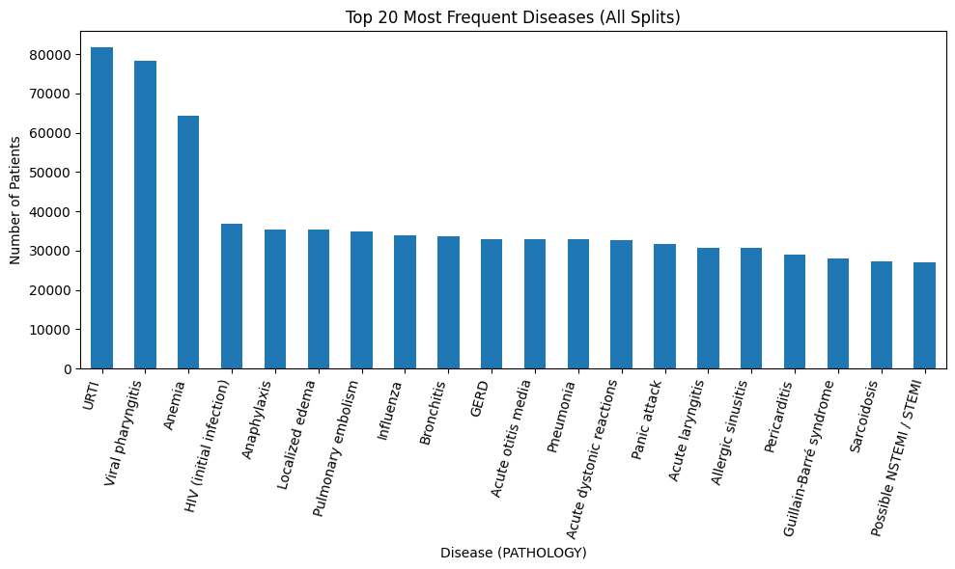Fig 2: Top 20 most frequent Disease in all splits.
Fig 2 presents three histograms of the distribution of the ages of patients in the train, validation and test sets. The sample size of the training set is very large and the ages are very wide and ranging between early childhood up to more than 100 years of age and majority of the patients are between 15-60 years. Sample sizes in the validation and test sets are much smaller, however, they are distributed in the similar way as in the training set with the wide scattering of sample over all adult age groups and limited observations at the extremes. The plots, on the whole, indicate that the three splits are age-diverse and exhibit a steady underlying age pattern although the validation and test sets consist of much less patients.
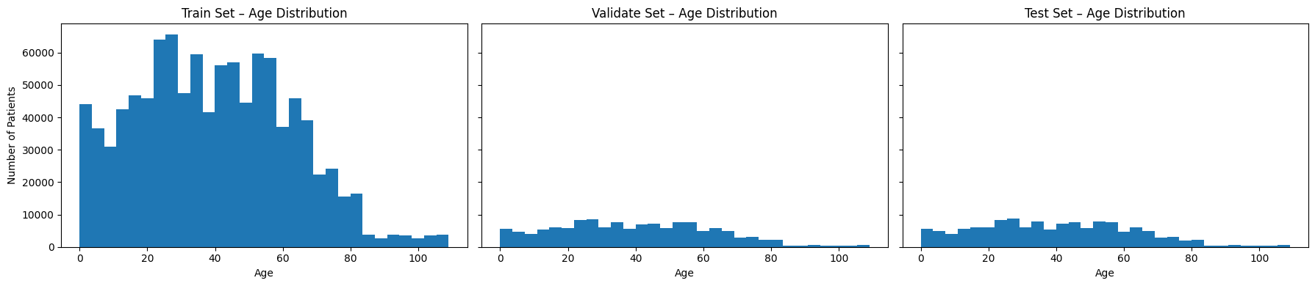Fig 3 : Age distribution in all the splits.
Fig 3 shows the number of evidence tokens (symptoms, signs, lab findings, etc.) in each patient train, validation and test sets. The average evidence per patient in the training set to be used is around 10 to 35 with the average lying between 18 to 25 evidence as the popular range. This is an expression of deep clinical descriptions patient by patient, and a steady trend of an intermediate evidence level. The validation, and test sets are smaller, but they exhibit the same shape: the majority of patients possess between 10 and 30 evidences, with a slight reduction to the upper end. Some records contain over 35 evidences, and these are uncommon. On the whole, the plots demonstrate that the similar distributions of counts of evidence are observed in all the three splits, which means that evidence splitting has been done in a balanced and representative manner.
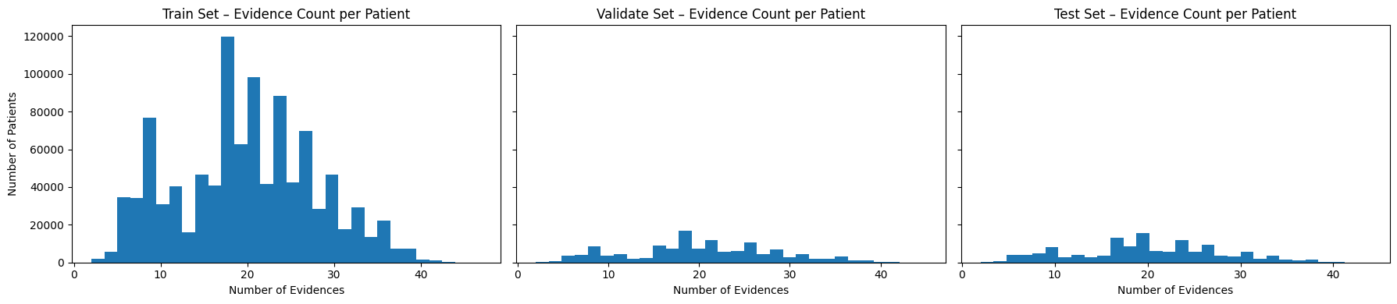Fig 4 : Distribution of Evidence Count per Patient Across Train, Validation, and Test Sets.
Figure 4 above displays the 20 most repeated evidence tokens (symptoms, signs, or clinical features) across the whole dataset. The numbers in each bar indicate the number of records in the patient records that have a particular evidence code. The most frequent record is E204_@V10, which happens over 1.2 million times in patient records, which shows that this symptom or clinical phenomenon is very common in the dataset. The other most common evidences, E53, E57at V123, E66 and E201 all have an appearance between 400,000 and 1,000,000 times indicating that these symptoms create the central clinical data in most of the cases. Next we begin to see fewer evidence tokens heading towards the right of the chart, but the least common ones in the top 20 still are found about 170,000-220,000 times. It means that the dataset consists of a combination of a very high and moderately frequent clinical feature, which gives the model a rich collection of diagnostic indicators. In general, the plot shows that there is a huge disproportion in the use of evidence with a few symptoms prevailing over most of the data, which is true in practice as common symptoms (cough, fever, or general discomfort) are present in most diseases.
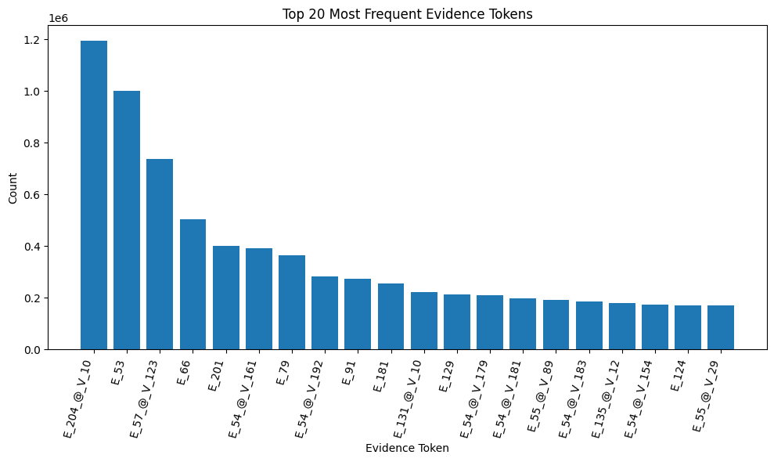Fig 5 : 20 most frequently occurring evidence.
The 20 most common evidences are represented in figure 5 with the top 20 in human-readable form rather than coded tokens. As the chart indicates, the most frequent questions asked by patients include travel history, the existence of pain, cough, fever, nasal congestion, and difficulty in breathing that are repeated most frequently throughout the data set. These high-frequency symptoms are typical of clinical manifestation in emergency and primary care, and are similar to coded distribution in the plot above.
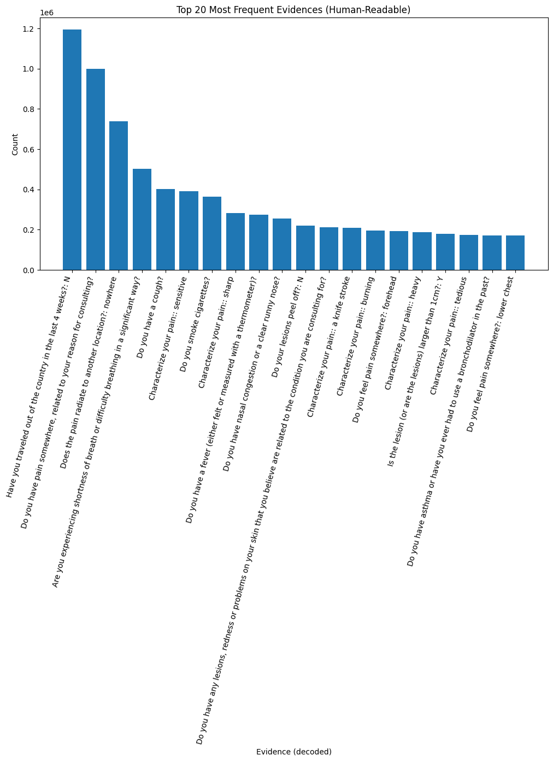
Fig 6 : 20 most frequent evidences (Human Readable)
Workflow:
First of all, we began with the importation of several libraries on machine learning. MultiLabelBinarizer is the most significant one that converts lists of evidence tokens into machine readable vectors. Text labels are converted to integers using labelencoder. LogisticRegression was used as a control ML classifier.
Then we started with mapping condition Id’s to disease information. For example :
"C_32":
"name": "Pneumonia",
"category": "Respiratory infection",
"severity": "medium"
We also mapped the evidence Id’s to their metadata.
"E_53":
"name": "Fever",
"type": "binary",
The dataset has two important sources of metadata such as release conditions.json and release evidences.json that act as the structural dictionary of the diagnostic system. The conditions file has 49 different diseases each of which has a condition identifier, a standardized ICD-10 code, the symptoms evidences, risk-factor antecedents, and severity score. As an illustration, the map of the condition of Spontaneous pneumothorax is resolved into a set of evidence identifiers that relate to such symptoms like chest pain, dyspnea, and fever in addition to antecedent conditions such as smoking or previous trauma. The evidences file has 223 evidence items; every one of these items describes a clinical finding (symptom), laboratory result, or medical history factor. Each token of the evidence (e.g., E_91) has a human-readable question in English, type of the data (binary or categorical or numerical), and information on whether the token is a current symptom or a medical antecedent. The combination of these metadata files enables the machine-learning system to convert encoded CSV patient records into useful clinical information, which can be used to establish accurate differential diagnosis models.

Feature engineering:
The target variable is pathology. The metadata of conditions are loaded into a readable data frame. We encode the categorical strings with the help of machine friendly integers. We assume all the different pathology and ascribe them to different Id. This is made into a column new to be used as y in training. The PATLOG in the CSV is a string hence it is coded in numbers.
train_evidence_lists = patients_all.loc[patients_all["split"] == "train", "EVIDENCE_LIST"]
mlb = MultiLabelBinarizer(sparse_output=True)
Based on the training data all the evidence list is taken and multi-hot encoding is done. We remove tokens in the evidence list and MultiLabelBinarizer retrains a vocabulary and turns lists into sparse multi-hot feature vectors.
The demographics of age and sex were converted into a numerical feature. We encoded age and sex. Filling any missing values, also. And in case there are any gaps in age values; we impute it with median age. These values too are the inputs X that is equal to our models as well as the evidence tokens. Then we add them to the evidence feature vectors which we created above.
Last but not least we generate the real machine-learning data. EVIDENCE_LIST This is a Python list such as [' E_48', E 53, E 54 at V 161,... ]. This has been converted to a huge sparse binary vector using mlb (MultiLabelBinarizer). We set the X input features that are Multi-hot encoded evidence tokens,Age (numeric),Sex (numeric). And y (target labels) integer encoded pathology labels of LabelEncoder. AGE (like 18, 32, 44…) SEX (0 = F, 1 = M) are transformed into column vectors in order to be summed with the multi-hot features of evidence.
Model Training :
logistic regression classifier :
We now train the baseline model of machine-learning: a multinomial logistic regression binary-classifier, which is appropriate when the problem is large with multi-classes with the feature vectors sparse and high-dimensional as is the case with the evidence token generated feature vectors. The model is configured using the solver:saga, which is a state-of-the-art optimization solver that is tailored to scale to very large sparse matrices, and thus can be used with your multi-hot representations of evidence. The max-iter=200 parameter specifies the number of iterations the solver will bother and look for the best model weights, and n-jobs= -1 permits parallel calculation and use all the possible CPU cores. To monitor convergence, it is just necessary to set verbose=1 to be able to see the progress updates in training. Lastly, clf.fit(X_train, y_train) executes the very action of learning: it takes as input the training feature matrix (X_train) and the disease labels (y_train) and identifies the solution to the weight parameters that best classify the various pathologies, using the evidence patterns, age and sex.
The first reason we use multinomial logistic regression is that it is the simplest and fastest and most reliable base model on a large multi-class medical dataset as in this case. It can be trained very fast, requires almost no tuning, works very well on very sparse evidence vectors and you know instantly whether your feature engineering (evidence + age + sex) is useful or not. Concisely, it provides you with a clean sanity-check model: when logistic regression is working, then more sophisticated models (XGBoost, LightGBM, deep learning) will certainly be even better performing. It is the least risky point in which to begin with before progressing to heavier and more complex models.
Training Multiple Classical Machine Learning Models :
Now we explain how various classical ML models perform and takes time to train them using the same dataset. The first stage involves the development of a dictionary, named models, whose keys are the model names, and whose values are scikit-learn classifiers with particular hyperparameters. Next, within the loop, every model is trained on X train, y train and training time is recorded as time.time. Once the code has been trained, code probabilities are obtained: in the case that the model supports predict_proba, this is used directly; otherwise (when using LinearSVC) the result is the score of the decision_function converted to pseudo-probabilities with a softmax (exp(scores) / sum(exp(scores)). To measure this it loads the predict() method and measures top-1 accuracy on both validation and test sets, and top-k accuracy (top-1, top-3, top-5) on the probability matrices with the helper topk_accuracy. All metrics and the training time are kept in a list of dictionaries, transformed into a DataFrame results_df, and shown in a clean summary table with the way each of the models performs.
RandomForestClassifier:
RandomForest model is an expression of a large number of decision trees which are trained on a random subset of samples and features. In this case it is made by means of estimators=200, i.e. by building 200 trees, which tends to enhance both stability and performance at the price of increased calculation. Jobs =-1 informs scikit-learn to utilize all the available CPU cores expediting training. Random forests are able to model the non-linear relationships and interactions between evidences, age and sex, and resistance to noisy features, so they are also a powerful non-linear baseline relative to logistic regression.
RidgeClassifier:
RidgeClassifier is a linear classifier that is equivalent to logistic regression except that it is optimized with a squared-loss formulation with L2 regularization (ridge). It solves the multi-class problem slightly differently (through one-vs-rest internally) but is otherwise quite fast and it works well with high dimensional sparse data. The default regularization is used in this configuration and no additional hyperparameters have been stated. Ridge is another linear lower limit and at times it may be superior to logistic regression when the classes are not separable linearly, but the features are very much interrelated.
SGDClassifier:
SGDClassifier(loss=log loss) is logistic regression that is trained using stochastic gradient descent and can scale very well in large dataset. It does not solve the optimization problem in a single batch, but, rather, in mini-batches. The penalty=l2, max_iter=10, and n_jobs=-1 are (l2) regularization, a limit of 10 passes through the data and parallelization of certain inner processes. This is a highly scalable alternative to regular LogisticRegression (particularly when max iter is large), and is valuable to determine whether an approximation learner can achieve similar accuracy with the DDXPlus dataset in less time.
LinearSVC:
LinearSVC is a linear Support Vector Machine of classification. In contrast with them, it does not necessarily give probabilities, just decision scores (distance to the decision hyperplane). This is why the code hasattr(model, "predict_proba"), and in the case of LinearSVC the outputs of decision functions were used and the softmax is used to estimate the class probabilities of the best-k measures. Linear SVMs can be quite effective on sparse and high-dimensional data and are capable of providing a powerful linear baseline that is independent of logistic-type models.
Results:
Overall Model Performance:
The results of the experiment indicate that the suggested evidence-based model of the differential diagnosis has the exceptionally high predictive accuracy when used with diverse machine-learning models. Top-1 accuracy was nearly perfect in most cases on the validation dataset and test dataset and Top-3 and Top-5 accuracies were always of values of 1.0000. This is to show that the right pathology was nearly always within the top-ranking diagnosis prediction.
It is especially important in a clinical differentiation diagnosis, where a physician is often trying to think about a list of possible diseases, as opposed to making use of one potential outcome. The findings affirm that the framework is capable of learning well-structured patterns of discrimination on the basis of structured patient features along with metadata-generated clinical evidence.
Linear and Margin Based Model Performance:
Linear models, such as LinearSVC, SGDClassifier, and RidgeClassifier, had high and consistent results on all measures of evaluation. LinearSVC was one of the best performing in terms of Test Top-1 (0.9974) and had flawless Top-3 and Top-5 accuracy.
This is due to the fact that margin-based classifiers are particularly effective against high-dimensional sparse evidence-based feature space. When there are sufficient training samples, clinical evidence tokens and the encoded metadata form linearly separable boundaries in their decision making. Therefore, such models generalise and have low variance due to validation and test results, and this is an indication of low overfitting.
This decrease in Top 1 accuracy of RidgeClassifier (0.9854) could also be due to the fact that squared -loss optimisation is less sensitive to class imbalance and irregular feature distributions than hinge -loss based classifiers like LinearSVC.
The Ensemble and Tree-Based Models:
The models that have the highest overall performance were random Forest and XGBoost with the XGBoost achieving the best Test Top-1 accuracy (0.9976), Top-3 and Top-5 accuracies at perfect. Similarly high results also proved to be achieved with random forest, which suggests that ensemble learning is an effective capture of multiple interactions of features in the dataset.
This evidence indicates that the metadata evidence representations that are produced by the framework interpret non-linear relationships among symptoms, antecedents, and diseases. The ensembles that are based on trees are well adapted towards modeling these interactions and will be able to achieve a higher Top-1 prediction accuracy in comparison with less complex linear classifiers and at the same time achieve high ranking performance.
Besides, the valuation versus test performances indicate the strength of the generalisation capability of ensemble methods trained with large but organised clinical data.
LightGBM Underperformance Analysis:
Unlike other tree-based models, LightGBM showed significantly worse performance whereby the Test Top -1 accuracy was at 0.0843. There are a number of reasons this discrepancy can be explained by. To begin with LightGBM is very sensitive in terms of feature distribution, sparsity behaviour and
hyperparameter tuning. The default histogram-based splitting implementation of LightGBM might not work well with binary and sparse encoding of tokens of clinical evidence. Second, the huge multi-class status of the problem (49 pathologies) adds a higher level of complexity to optimisation processes, making it susceptible to inaccurate convergence until the parameters are optimally evaluated.
This finding reveals the fact that model complexities do not necessarily imply high performance because it is important to compare model assumptions and assumptions with data properties in clinical machine-learning systems.
Clinical implications of high top-K Accuracy:
The observed consistent Top-3 and top-5 accuracies in most of the models have clinical implications. Although there are the rare cases when the highest ranked diagnosis is not the correct one, this true pathology is almost always among the first few predictions. This is in agreement with the real world diagnostic processes where clinicians have a range of plausible conditions in their minds before they can order the verification tests.
Thus, the suggested framework does not only exhibit a high level of predictive accuracy but also renders practicing clinical decision support, which ensures safer and more accurate diagnostic reasoning over a vast number of diseases.
Summary of Key Findings:
- Altogether, the findings help to conclude that the suggested framework:
- Scales are efficient to 49 pathologies.
- Performs almost flawless Top-K diagnostic performance.
- Extrapolates effectively in regard to invisible data of patients.
- Gives interpretable, ranked differential diagnosis that can be used in practice.
These results confirm the possibility of the framework being integrated into elicitable evidence-based clinical decision support systems.
An Interpretability Motivation More than an Accuracy Motivation:
Quantitative analysis indicated that the majority of models achieved almost perfect Top-K performance with Top-3 and Top-5 performance being within or equal to 1.0000 in both validation and test data. Although these outcomes testify to the strength and selective ability of the offered framework, even the immensely high accuracy does not provide much information about the mechanistic behavior and inner decision-making of the models.
In actual clinical situations, predictive accuracy needed needs to be supported with a clear line of thought since a clinician has to understand the basis of a clinical recommendation before they will trust or react on it. This led the near-saturated accuracy to place a distinct qualitative examination of interpretation compared to model and human-artificial interaction, as opposed to additional number optimization of performance.
Reason behind a Chatbot-Based Discovery:
Due to the good overall results, this paper suggests a novel extension the idea of implementing the trained diagnostic model as a conceptual model into a clinical decision-support chatbot. The goal was not to create a fully functional conversational agent but to test the hypothesis of whether the trained model can produce human-readable clinical reasoning on the basis of its representations of the internal evidence.
An approach like this is consistent with the new trends in explainable AI (XAI), where models should be able to explain the predictions with structured interpretable information. The existence of metadata coded evidences in the dataset gives a rare chance of being able to convert the symbolic evidence tokens into natural language descriptions hence giving the base to explainable conversational systems.
Human-readable Clinical Evidence Extraction:
To explore this potential, to generate readable diagnostic statements, a post-hoc interpretability pipeline, which transforms encoded clinical evidences into readable diagnostic statements, was developed. By using evidence metadata repository, the identifiers of raw evidence (e.g., E 55 V 108 ) were translated into the clinical questions and meaning of values.
Through the process, it was possible to reconstruct patient specific clinical stories, where each evidence token was transformed into a medically significant sentence. As a result, model inputs might be formulated in the form that would be readily understandable by clinicians, as well as non-technical users.
Top-K Misclassification Scenario Analysis:
Instead of giving attention to cases that were correctly predicted, the analysis read between the clinically realistic errors situations, i.e., cases whereby, the Top-1 prediction was inaccurate, whilst the true diagnosis would be found among the Top-5 predictions. These examples are especially relevant to the field of differential diagnosis, which is a manifestation of real-world uncertainty of clinically similar disorders. The model, in all validation cases, tended to confuse the model closely related disease pairs, e.g.
Differences between acute and chronic rhinosinusitis.
Stable vs. Unstable angina
However, in such cases, the appropriate diagnosis was still contained in the highest-placed predictions, which displays the ability of the model to reduce the diagnostic search space successfully.
Generated Explanations:
The evidence outputs that could be read by man showed that misclassifications mostly were the results of similar symptom profile, not arbitrary or spurious logic. For instance:
Evidences also included in rhinosinusitis case patients consisted of facial pain, nasal stuffiness, anosmia, sinus pressure, and history of allergy - all of which are typical of both acute and chronic forms. Shared presentations greatly explained the bewilderment between stable and unstable presentation in the case of angina through suspected common evidences like chest pain, radiation patterns, exertion-related symptoms, and cardiovascular risk factors. Notably, the evidence lists are offering clinically plausible reasons of the projected and actual states, which indicate that the mental rationale of the model is congruent with previously accepted medical knowledge and, thus, it can be trusted.
Explainable Clinical Chatbots Implications:
The ability of the trained model to transform encoded evidences into explanations comprehensible to humans proves that transparent and evidence-based dialogue can be facilitated by the trained model. This confirms the attainability of AI-based clinical chatbots that are able to: list ranked differential diagnoses, provide an explanation based on patient-specific evidence, and assist clinicians and not substitute clinical judgment. Even though the implementation of chatbots is out of the reflection of this paper, the findings testify that the proposed framework provides a powerful underlying layer of explainable conversational agents within the medical field.

Discussion:
The results of this study show that machine-learning models that are evidence-based can achieve very high diagnostic accuracy when they are used to solve very challenging multi-classes differential diagnosis problems at very large scale. The constant high-Top -1 and almost perfect Top -K accuracies in several model families demonstrated that the proposed framework is very effective in capturing the complex relationships between patient attributes, clinical evidences, and disease outcomes.
The evidenced predictive accuracy saturation, however, highlights a larger shortcoming of clinical machine-learning systems in general: the use of performance measures is insufficient to operate in a real-world setting. Under the healthcare framework, the matters of trustworthiness, transparency and interpretability are all equally valuable properties as compared to raw accuracy. Therefore, this research further expanded its analytical gaze past the traditional measures of evaluation, to explain the lines of reasoning of the model in the detection of diagnostic decisions.
A qualitative analysis of Top-K misclassification cases showed that most errors in prediction were found between conditions that were clinically proximate, e.g. acute and chronic rhinosinusitis or stable and unstable angina. They are overlaps that are indicative of real diagnostic ambiguity, but not of defects in the models. Such differences are often addressed in daily clinical practice with the help of longitudinal patient history, laboratory research, or imaging studies- data which was intentionally avoided by this study. Therefore, the model behavior is in line with realistic clinical reasoning, which strengthens its external validity.
In addition, the fact that a set of encoded evidence tokens can be turned into human-readable clinical narratives showed that the internal representations of the model can be intrinsically interpretable together with any structured metadata. The resulting explanations have agreed with existing medical knowledge and they reported logical patterns of symptoms and risk factors that supported the ranked diagnoses. The interpretability level at such a high level is required in order to ensure the collaboration of humans with AI in the future, where clinicians will need to question and test AI-made recommendations.
Even though the chatbot-based exploration was not used as a functioning system, it represents a phenomenal conceptual input. It demonstrates that effective diagnostic models can be redesigned to enable explainable and conversational clinical decision support, thus transforming the artificial intelligence role as a black box predictor to that of an interactive reasoning advisor. This is in line with new demands of responsible and explainable AI in the medical industry.
Conclusion:
This dissertation has proposed a machine-learning infrastructure based on evidence that has demonstrated ability to produce ranked diagnostic prediction in 49 different pathologies on large scale. Empirical findings also confirm that several of the classifiers, especially Top-K with ensembles and margin-based classifiers, can perform with near-perfect results, which supports the soundness and applicability of the proposed methodology.
In addition to quantitative measurements, the paper resolves the severe lack of interpretability and clinical reasoning in modern diagnostics. Using metadata acquired clinical evidences, the framework is capable of interpreting the encoded model inputs to transparent, human-readable explanations thus offers clear justifications to make diagnoses. Statistical results of misclassification cases also support the idea that errors in the model are clinically plausible and consistent with diagnostic problems in the real-world.
Driven by the plateau of performance measures of accuracy the study suggests a new conceptual extrapolation to explainable clinical chatbots, whereby trained models can support dialogue, evidenced based, diagnostic thinking. Even though the application of chatbots falls outside the scope of the presented work, the obtained findings support the viability of this type of systems and provide a strong basis of further development.
Overall, the presented work provides a scaled, interpretable, and clinically congruent diagnostic model that will bring machine-learning-based differential diagnosis to the next level. This approach allows the proposed methodology to bring one step closer to achieving the aim of practical, trustworthy AI-assisted healthcare decision support by integrating both high predictive performance with human-readable clinical evidence.
References:
- Leeds, F. S., Atwa, K. M., Cook, A. M., Conway, K. A., & Crawford, T. N. (2020). Teaching heuristics and mnemonics to improve generation of differential diagnoses. Medical Education Online, 25(1). https://doi.org/10.1080/10872981.2020.1742967
- Harada, Y., Katsukura, S., Kawamura, R., & Shimizu, T. (2021). Effects of a Differential Diagnosis List of Artificial Intelligence on Differential Diagnoses by Physicians: An Exploratory Analysis of Data from a Randomized Controlled Study. International Journal of Environmental Research and Public Health, 18(11), 5562. https://doi.org/10.3390/ijerph18115562
- Bhatt, D., Ayyagari, S., & Mishra, A. (2024). A Scalable Approach to Benchmarking the In-Conversation Differential Diagnostic Accuracy of a Health AI. arXiv preprint arXiv:2412.12538.
- Jeong, Y. S., Jeon, M., Park, J. H., Kim, M. C., Lee, E., Park, S. Y., Lee, Y. M., Choi, S., Park, S. Y., Park, K. H., Kim, S. H., Jeon, M. H., Choo, E. J., Kim, T. H., Lee, M. S., & Kim, T. (2021). Machine-Learning-Based Approach to Differential Diagnosis in Tuberculous and Viral Meningitis. Infection & chemotherapy, 53(1), 53–62. https://doi.org/10.3947/ic.2020.0104
- Miyachi, Y., Ishii, O., & Torigoe, K. (2023). Design, implementation, and evaluation of the computer-aided clinical decision support system based on learning-to-rank: collaboration between physicians and machine learning in the differential diagnosis process. BMC medical informatics and decision making, 23(1), 26. https://doi.org/10.1186/s12911-023-02123-5
- Cao, S., Yang, S., Chen, B., Chen, X., Fu, X., & Tang, S. (2024). Establishing a differential diagnosis model between primary membranous nephropathy and non-primary membranous nephropathy by machine learning algorithms. Renal failure, 46(2), 2380752. https://doi.org/10.1080/0886022X.2024.2380752
- Perovnik, M., Vo, A., Nguyen, N., Jamšek, J., Rus, T., Tang, C. C., ... & Eidelberg, D. (2022). Automated differential diagnosis of dementia syndromes using FDG PET and machine learning. Frontiers in aging neuroscience, 14, 1005731.
- Schulte‐Rüther, M., Kulvicius, T., Stroth, S., Wolff, N., Roessner, V., Marschik, P. B., ... & Poustka, L. (2023). Using machine learning to improve diagnostic assessment of ASD in the light of specific differential and co‐occurring diagnoses. Journal of Child Psychology and Psychiatry, 64(1), 16-26.
- Greco, A., Chiesa, M. R., Da Prato, I., Romanelli, A. M., Dolciotti, C., Cavallini, G., ... & Bongioanni, P. (2021). Using blood data for the differential diagnosis and prognosis of motor neuron diseases: a new dataset for machine learning applications. Scientific Reports, 11(1), 3371.
- Kim, N. Y., Jang, B., Gu, K. M., Park, Y. S., Kim, Y. G., & Cho, J. (2024). Differential diagnosis of pleural effusion using machine learning. Annals of the American Thoracic Society, 21(2), 211-217.
- Kim, J., Baek, H.-S., Ha, J., Kim, M. K., Kwon, H.-S., Song, K.-H., Lim, D.-J., & Baek, K.-H. (2022). Differential Diagnosis of Thyrotoxicosis by Machine Learning Models with Laboratory Findings. Diagnostics, 12(6), 1468. https://doi.org/10.3390/diagnostics12061468
- Cha, D., Pae, C., Lee, S. A., Na, G., Hur, Y. K., Lee, H. Y., ... & Park, H. J. (2021). Differential biases and variabilities of deep learning–based artificial intelligence and human experts in clinical diagnosis: Retrospective cohort and survey study. JMIR Medical Informatics, 9(12), e33049.
- Harada, Y., Katsukura, S., Kawamura, R., & Shimizu, T. (2021). Efficacy of Artificial-Intelligence-Driven Differential-Diagnosis List on the Diagnostic Accuracy of Physicians: An Open-Label Randomized Controlled Study. International Journal of Environmental Research and Public Health, 18(4), 2086. https://doi.org/10.3390/ijerph18042086
- Cau, R., Pisu, F., Suri, J. S., Montisci, R., Gatti, M., Mannelli, L., Gong, X., & Saba, L. (2024). Artificial Intelligence in the Differential Diagnosis of Cardiomyopathy Phenotypes. Diagnostics, 14(2), 156. https://doi.org/10.3390/diagnostics14020156
- Niu, S., Huang, J., Li, J., Liu, X., Wang, D., Zhang, R., ... & Zhu, J. (2020). Application of ultrasound artificial intelligence in the differential diagnosis between benign and malignant breast lesions of BI-RADS 4A. BMC cancer, 20(1), 959.
- Ferrara, M., Franchini, G., Funaro, M., Cutroni, M., Valier, B., Toffanin, T., ... & Grassi, L. (2022). Machine Learning and Non-Affective Psychosis: identification, differential diagnosis, and treatment. Current Psychiatry Reports, 24(12), 925-936.
- van Oosterzee, A. AI and mental health: evaluating supervised machine learning models trained on diagnostic classifications. AI & Soc 40, 5077–5086 (2025). https://doi.org/10.1007/s00146-024-02012-z
- Zhou, S., Lin, M., Ding, S. et al. Explainable differential diagnosis with dual-inference large language models. npj Health Syst. 2, 12 (2025). https://doi.org/10.1038/s44401-025-00015-6
- Kim, S.H., Wihl, J., Schramm, S. et al. Human-AI collaboration in large language model-assisted brain MRI differential diagnosis: a usability study. Eur Radiol 35, 5252–5263 (2025). https://doi.org/10.1007/s00330-025-11484-6
- Niyonizeye, E., Wang, X., Yan, D. et al. Building a new score system for the diagnosis and differential diagnosis of typical CLL/SLL, atypical CLL/SLL, and MCL based on the flow cytometry immunophenotyping. Ann Hematol 104, 1807–1819 (2025). https://doi.org/10.1007/s00277-025-06231-2
- Stoian, D., Moisa-Luca, L. & Bena, A. Qualitative and quantitative CEUS assessment for differential diagnosis in thyrotoxicosis: destruction vs. hyperfunction. Endocrine 90, 199–207 (2025). https://doi.org/10.1007/s12020-025-04324-6
- Jung, J., Phillipi, M., Tran, B. et al. Accuracy of large language models in generating differential diagnosis from clinical presentation and imaging findings in pediatric cases. Pediatr Radiol 55, 1927–1933 (2025). https://doi.org/10.1007/s00247-025-06317-z
- Jia, H., Tang, S., Guo, W. et al. Differential diagnosis of congenital ventricular septal defect and atrial septal defect in children using deep learning–based analysis of chest radiographs. BMC Pediatr 24, 661 (2024). https://doi.org/10.1186/s12887-024-05141-y
- Zhang, S., Qin, P. & Ji, H. Differential diagnosis of gastrointestinal stromal tumors versus leiomyomas by special stains. BMC Gastroenterol 24, 418 (2024). https://doi.org/10.1186/s12876-024-03511-5
- Luo, R., Yang, G., Shi, H. et al. A Stepwise decision tree model for differential diagnosis of Kimura’s disease in the head and neck. BMC Med Imaging 25, 90 (2025). https://doi.org/10.1186/s12880-025-01618-z

